1. **Introduction**

**1.1 Project Overview**

The fake/genuine logo detector project leverages deep learning methodologies, specifically utilizing the VGG19 architecture and transfer learning techniques. The primary objective is to create an intelligent system capable of distinguishing between authentic and counterfeit logos with high accuracy. This initiative addresses the escalating concerns surrounding counterfeit products and fraudulent branding, aiming to assist businesses and consumers in verifying the authenticity of logos.

**1.2 Purpose**

The purpose of this project is to develop an advanced machine learning model that can accurately identify and classify logos as either genuine or fake. With the proliferation of counterfeit goods and fraudulent branding in various industries, there exists a pressing need for an automated and reliable solution to authenticate logos. By harnessing deep learning capabilities and transfer learning from pre-trained models like VGG19, this project endeavours to create a robust and scalable system capable of discerning minute variations in logos, thereby aiding in the mitigation of counterfeit practices.

This project's significance lies in its potential to empower businesses, brand owners, and consumers by providing a tool that enhances trust and confidence in the authenticity of branded products and materials.

1. **Literature Survey**

**2.1 Existing Problem**

The issue of counterfeit products and fraudulent branding has been a persistent challenge across various industries. Counterfeit goods not only infringe upon intellectual property rights but also pose significant risks to consumer health and safety. The existing methods of detecting counterfeit logos often rely on manual inspection, which is time-consuming, subjective, and prone to errors. Moreover, the rapid advancement in technology has led to more sophisticated counterfeit practices, necessitating a robust and automated solution to authenticate logos with precision.

**2.2 References**

During the course of this project, a comprehensive review of relevant literature and resources was conducted. Several key references were consulted, including:

* **Article from ScienceDirect***:*

[*https://www.sciencedirect.com/science/article/abs/pii/S0010482522000804*](https://www.sciencedirect.com/science/article/abs/pii/S0010482522000804)

* **Article on classifying Potato infected leaves:**

<https://www.mdpi.com/2624-7402/4/4/56>

* Kataoka H, Iwata K, Satoh Y (2015) Feature evaluation of deep convolutional neural networks for object recognition and detection. <https://arxiv.org/abs/1509.07627>

**2.3 Problem Statement Definition**

The primary problem addressed in this project is the need for an automated and accurate method to distinguish between genuine and fake logos. The challenge lies in developing a deep learning-based model capable of analysing logo variations, textures, and subtle alterations that are indicative of counterfeit logos. The goal is to create a system that not only identifies counterfeit logos but also exhibits robustness against various image manipulations and transformations.

**3. Ideation & Proposed Solution**

3.1 Empathy Map Canvas

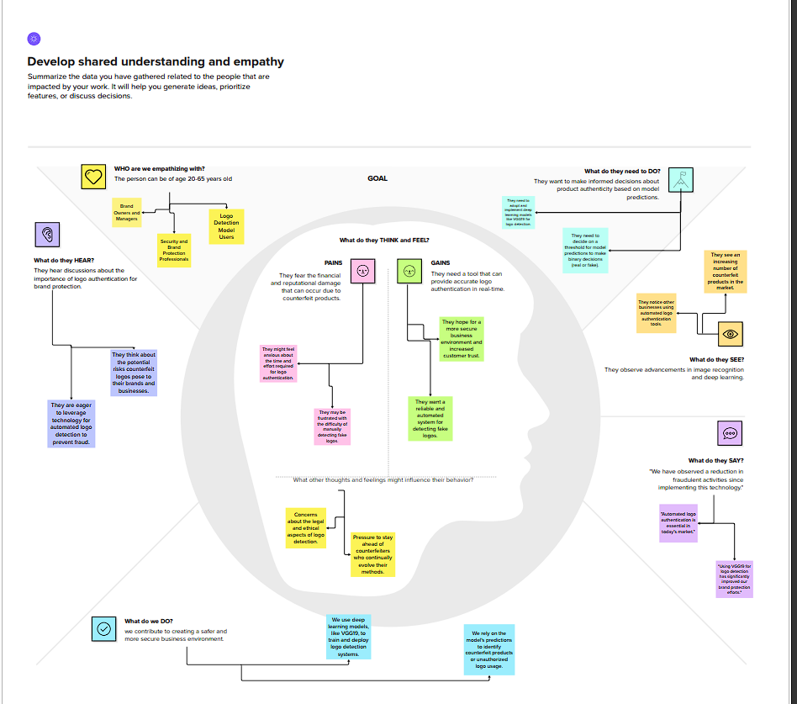

3.2 Ideation & Brainstorming

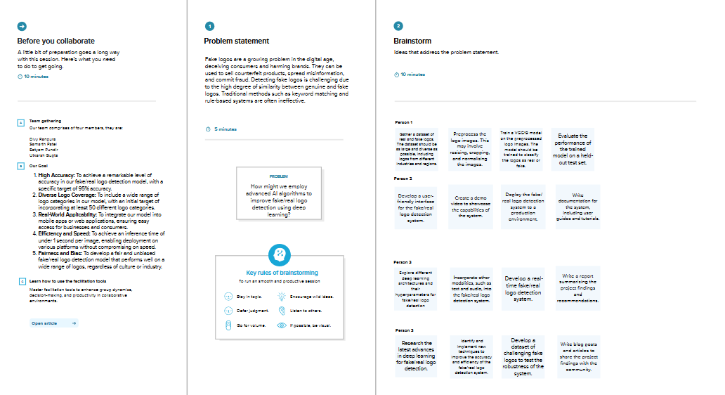

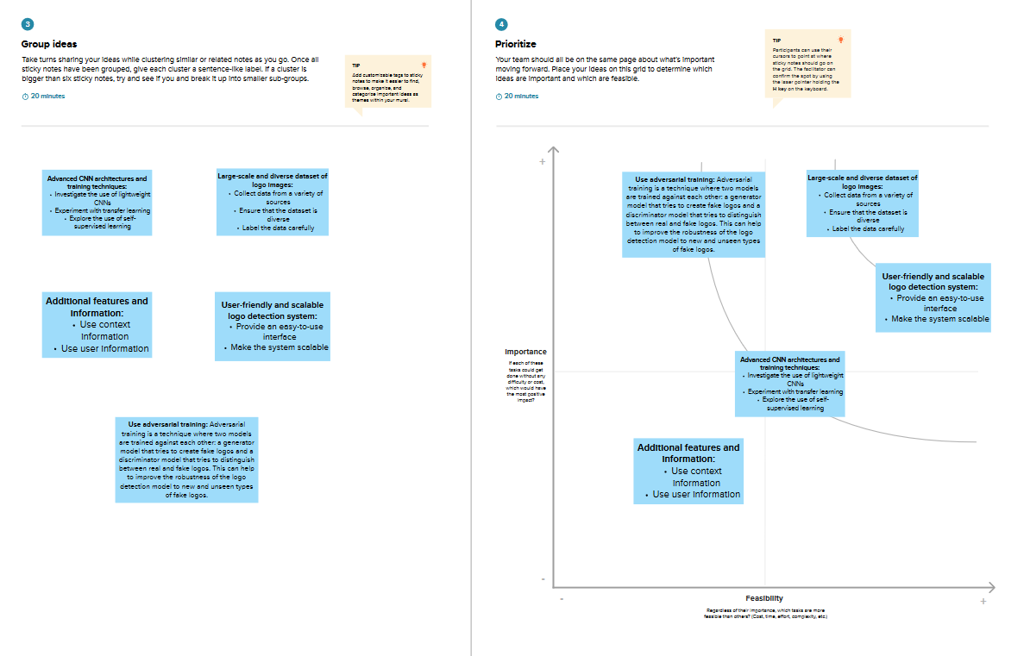

**4. Requirement Analysis**

**4.1 Functional Requirements**

4.1.1 Logo Classification

The system should be capable of accurately classifying logos into two categories: *genuine and fake.* It should handle various logo sizes, orientations, and backgrounds to ensure comprehensive classification accuracy.

4.1.2 Model Training and Validation

There should be a provision to train the model using VGG 19 transfer learning techniques on a diverse dataset of logos. Additionally, the system must support validation procedures to ensure the model's accuracy and reliability.

4.1.3 Real-time Inference

The solution should offer real-time inference capabilities, allowing users to upload or capture images for immediate logo authentication.

**4.2 Non-Functional Requirements**

4.2.1 Accuracy and Performance

The system must achieve a high level of accuracy in logo classification, with a target accuracy of at least 95%. It should also demonstrate efficient performance, ensuring quick inference times to meet user expectations.

4.2.2 Scalability and Robustness

The solution should be scalable to handle a growing dataset of logos and maintain its performance. Furthermore, it should exhibit robustness against various image distortions, noise, and alterations commonly associated with counterfeit logo attempts.

4.2.3 User Interface

The user interface should be intuitive, user-friendly, and accessible across different devices and platforms, facilitating easy interaction for both technical and non-technical users.

4.2.4 Security and Privacy

The system must ensure data security and user privacy, adhering to best practices and regulations concerning data handling, especially when dealing with sensitive information.

**5. Project Design**

**5.1 Data Flow Diagrams & User Stories**

5.1.1 Data Flow Diagrams

The data flow within the fake/genuine logo detector involves the following key steps:

* **Data Collection:** Logos are gathered from diverse sources, ensuring a wide variety of authentic and counterfeit examples.
* **Preprocessing:** The collected logos undergo preprocessing steps, including resizing, normalization, and augmentation to enhance model performance.
* **Training and Validation:** The pre-processed data is used to train and validate the deep learning model, employing the VGG19 architecture with transfer learning.
* **Inference:** Real-time logo images are fed into the trained model for inference to determine their authenticity.

5.1.2 User Stories

* As a user, I want to upload logo images to the system for authentication.
* As a brand owner, I want to verify the authenticity of my logo swiftly and accurately.
* As an administrator, I want access to model training logs and performance metrics for monitoring and improvement purposes.

**5.2 Solution Architecture**

5.2.1 Components

* **Data Collection Module:** Responsible for gathering and preprocessing logo datasets.
* **Model Training Module:** Utilizes transfer learning techniques with VGG19 to train the classification model.
* **Inference Engine:** Accepts user inputs and runs them through the trained model to classify logos.
* **User Interface:** Provides an intuitive platform for users to interact with the system.

5.2.2 Technologies Used

* **Deep Learning Framework:** Keras, TensorFlow, VGG19 Model
* **Programming Language:** Python
* **Web Framework:** Flask for building the user interface
* **Storage:** Utilizing cloud storage for dataset management

**5.2.3 Interaction Diagram**

The interaction diagram showcases the flow of data and operations between different system components during logo authentication.

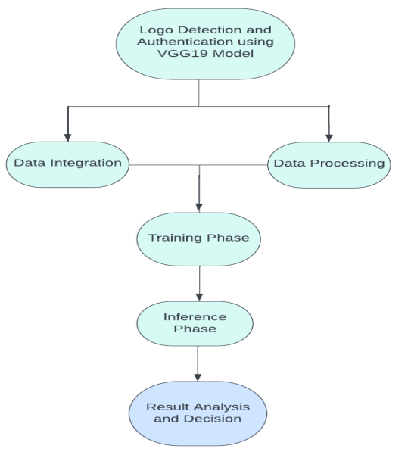

6. Project Planning & Scheduling

**6.1 Technical Architecture**

6.1.1 Development Methodology

The project will adhere to an Agile development methodology, utilizing Scrum practices. This approach allows for iterative development, frequent feedback loops, and adaptability to changing requirements.

6.1.2 Tools and Technologies

* **Version Control:** Git for code management and collaboration.
* **Development Environment:** PyCharm, VSCode, Jupyter Notebooks for coding and experimentation.
* **Deployment:** Docker containers for easy deployment and reproducibility.

**6.2 Sprint Planning & Estimation**

6.2.1 Sprint Duration

Sprints will be organized into two-week cycles to ensure regular progress updates and deliverables.

6.2.2 Sprint Backlog

Each sprint will have a defined backlog consisting of tasks such as data collection, preprocessing, model training, UI development, testing, and documentation.

6.2.3 Estimation Techniques

Effort estimation will be based on story points allocated to tasks, considering factors like complexity, dependencies, and risks associated with each task.

**6.3 Sprint Delivery Schedule**

6.3.1 Milestones

* **Sprint 1:** Data collection, preprocessing, and initial model training.
* **Sprint 2:** UI development, model validation, and initial system testing.
* **Sprint 3:** Refinement of UI, performance optimization, and final testing.
* **Sprint 4:** Documentation, final evaluation, and project deployment.

**7. Coding & Solutioning**

**7.1 Feature 1: VGG19 and Transfer Learning Implementation**

Description

Utilizing the VGG19 architecture pretrained on ImageNet, transfer learning techniques were employed to fine-tune the model for logo classification. The final layers of VGG19 were adapted and retrained on a custom dataset containing diverse logo images, allowing the model to learn intricate features specific to logo authentication.

Code Snippet:

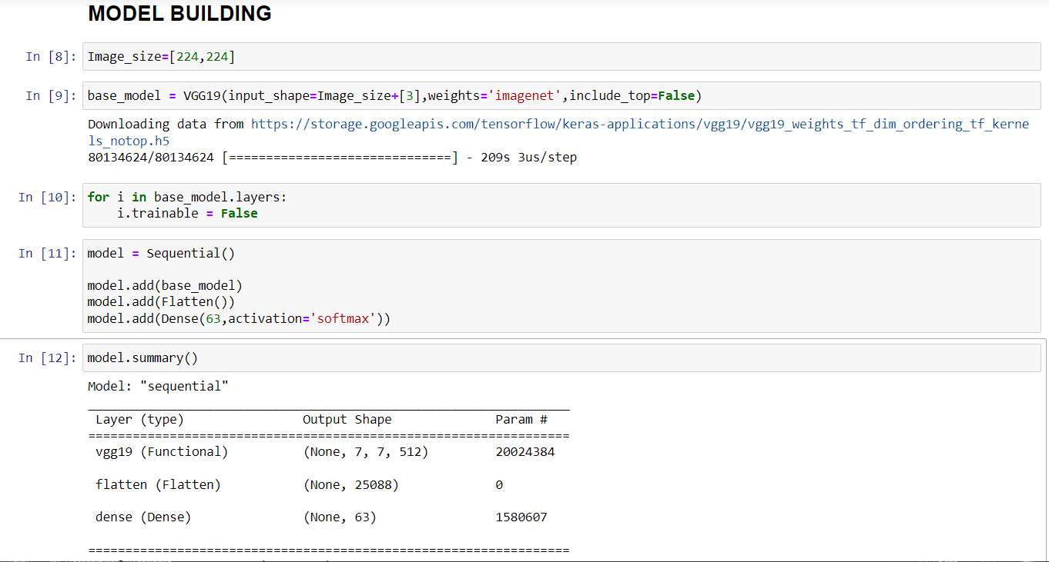

**7.2 Feature 2: Real-time Inference and User Interface**

Description

A user-friendly web interface was developed using Flask, allowing users to upload or capture images for instant logo authentication. The interface interacts with the trained model, providing seamless real-time inference capabilities. Users receive immediate feedback regarding the authenticity of the uploaded logo images.

Code Snippet:

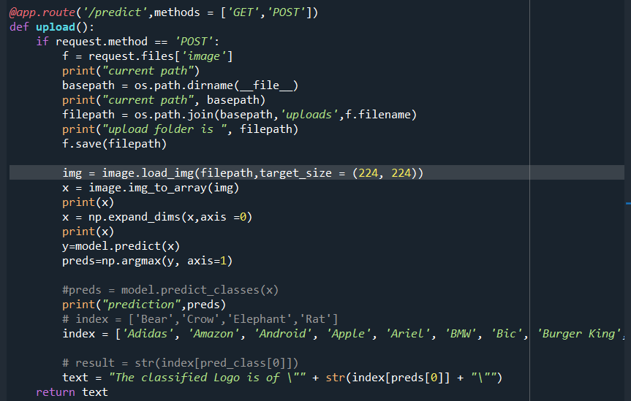

**8. PERFORMANCE TESTING**

**8.1 Performance Metrics**

|  |  |  |  |
| --- | --- | --- | --- |
| **S.No.** | **Parameter** | **Values** | **Screenshot** |
|  | Model Summary | **-** |  |
|  | Accuracy | Training Accuracy - 100 %  Validation Accuracy-96.83%  Loss: 0.0046 |  |

**9. Output Screenshots:**

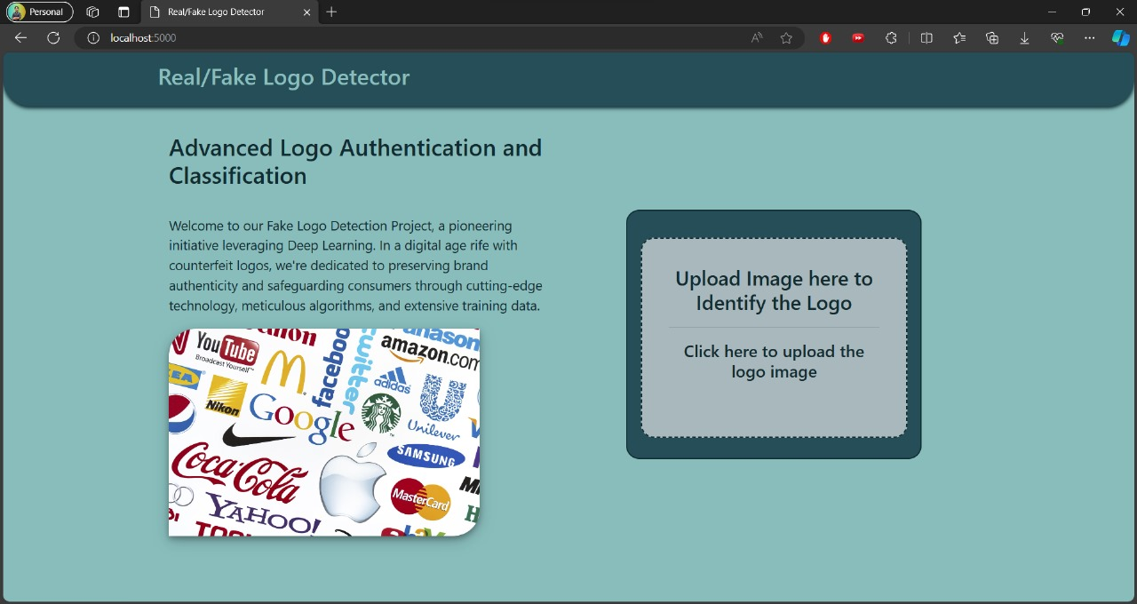

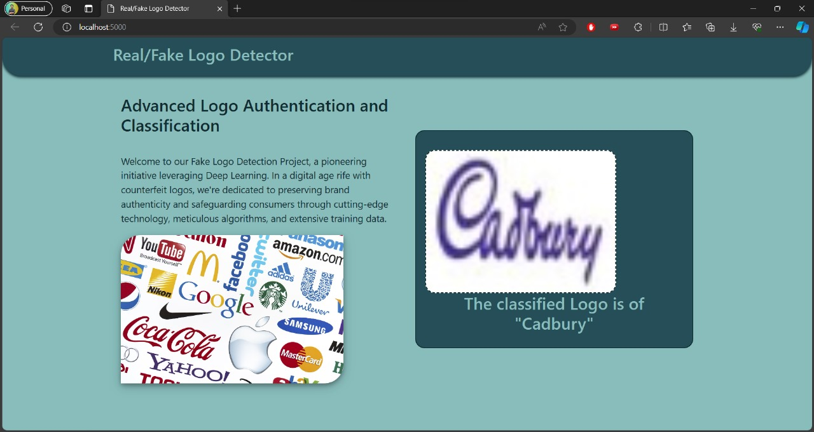

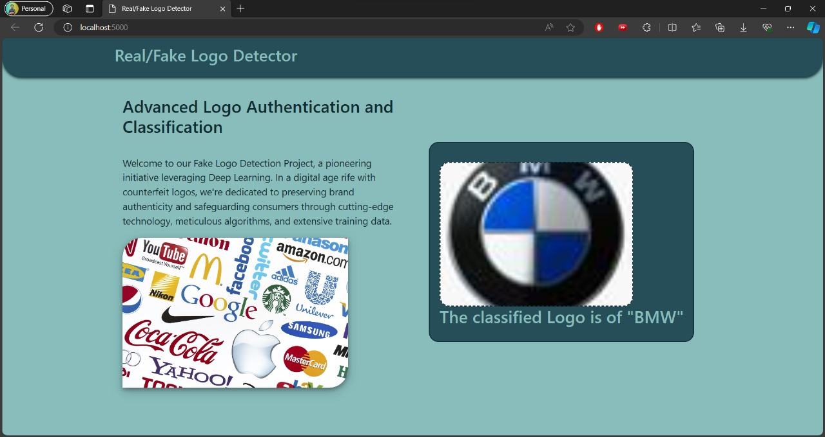

**10. ADVANTAGES & DISADVANTAGES**

**10.1 Advantages**

10.1.1 Accuracy

* **High Accuracy:** The model demonstrates a high accuracy rate in distinguishing between genuine and fake logos, providing reliable authentication results.

10.1.2 Real-time Inference

* **Real-time Inference:** The system offers swift and immediate logo authentication, enabling users to verify logos instantly.

10.1.3 Transfer Learning Benefits

* **Transfer Learning:** Leveraging pre-trained models like VGG19 speeds up the development process and allows the model to learn intricate features from large datasets.

10.1.4 User-Friendly Interface

* **User Interface:** The intuitive web interface ensures ease of use for both technical and non-technical users, facilitating seamless interaction.

**10.2 Disadvantages**

10.2.1 Dependency on Dataset Quality

* **Dataset Quality:** The model's performance heavily relies on the quality, diversity, and representativeness of the dataset used for training.

10.2.2 Interpretability

* **Interpretability:** Deep learning models, including the one employed here, might lack interpretability, making it challenging to comprehend the model's decision-making process.

10.2.3 Sensitivity to Image Variations

* **Sensitivity:** The model might exhibit sensitivity to image alterations, noise, or distortions, impacting its performance in certain scenarios.

10.2.4 Computational Requirements

* **Computational Resources:** Deep learning models like VGG19 demand significant computational resources for training and inference, potentially limiting deployment on resource-constrained devices.

**11. CONCLUSION**

The development and implementation of the fake/genuine logo detector leveraging deep learning techniques have yielded promising results. The project aimed to address the critical issue of counterfeit products and fraudulent branding by providing an automated solution for logo authentication.

Through the utilization of the VGG19 architecture and transfer learning methodologies, the system demonstrates commendable accuracy in distinguishing between genuine and fake logos. The real-time inference capabilities, coupled with an intuitive user interface, offer a user-friendly experience, enabling swift logo verification.

While the system showcases several advantages such as high accuracy and real-time inference, it's essential to acknowledge certain limitations. Dependency on dataset quality, interpretability challenges, and sensitivity to image variations are factors that need continuous attention and improvement.

Despite the identified limitations, the fake/genuine logo detector stands as a testament to the potential of deep learning in addressing authenticity concerns within branding and product authentication domains. Future enhancements in dataset diversity, model interpretability, and optimization techniques will further augment the system's capabilities and reliability.

In conclusion, this project lays a solid foundation for combating counterfeit practices by providing a robust and efficient solution for logo authentication. It contributes to fostering trust and confidence in brand authenticity, benefiting both businesses and consumers alike.

**12. FUTURE SCOPE**

The fake/genuine logo detection system lays the groundwork for further advancements and enhancements. Several potential avenues exist for future development and improvement, including:

**12.1 Dataset Expansion and Diversity**

* **Augmented Dataset:** Expanding the dataset with more diverse and comprehensive samples of logos, encompassing various industries and design variations, will enhance the model's generalization capabilities.

**12.2 Model Optimization**

* **Architecture Refinement:** Exploring and fine-tuning the model architecture, possibly exploring newer architectures beyond VGG19, to improve performance and efficiency.
* **Regular Updates:** Implementing a system for regular updates and retraining of the model to adapt to evolving counterfeit techniques and new logo variations.

**12.3 Interpretability and Explainability**

* **Explainable AI (XAI):** Investigating methods for enhancing model interpretability to provide insights into the model's decision-making process, ensuring better trust and understanding of the authentication results.

**12.4 Integration and Deployment**

* **Mobile Integration:** Adapting the system for deployment on mobile devices to provide on-the-go logo authentication, catering to a wider user base.
* **API Development:** Creating an API for seamless integration with e-commerce platforms and brand protection services.

**12.5 Collaboration and Expansion**

* **Collaborative Efforts:** Collaborating with industry stakeholders, brand owners, and regulatory bodies to implement the system as a standard tool for brand authentication and protection.
* **Expanded Use Cases:** Exploring applications beyond logo detection, such as document authentication or intellectual property protection.

**12.6 Performance Enhancement**

* **Performance Tweaks:** Continuous optimization efforts to improve model efficiency, reduce inference time, and enhance scalability for handling larger volumes of logo authentication requests.

The future scope of the fake/genuine logo detection system encompasses various dimensions of improvement, innovation, and collaboration, aiming to fortify brand authenticity measures and combat counterfeit practices across industries.

**13. APPENDIX**

**13.1 Source Code**

The source code for the fake/genuine logo detection system can be accessed on GitHub at the following repository link:

[GitHub Repository](https://github.com/smartinternz02/SI-GuidedProject-608900-1698075644)

**13.2 Project Demo**

A live demonstration of the fake/genuine logo detection system can be accessed via the following link:

[Project Demo](https://drive.google.com/file/d/1Zy4Hqkk3liya7ZXOReVUPGL3gXfbYalD/view?usp=sharing)